**Test Case** **0042**

**System:** VirtuCardsHost and VirtuCardClient

**Description:** Test whether vibration occurs when it is the current player’s turn

**Severity:** 2

**Instructions**

**Test 1**

1. Start VirtuCardClient application
2. Click the button labeled “Sign In”
3. Enter “virtucards01@gmail.com” into the text input labeled “Enter email…”
4. Enter “Testing1” into the text input labeled “Enter password…”
5. Press the button labeled “Login”
6. A window should appear saying “Login Success”
7. Press the OK button that appears on that window
8. Start VirtuCardHost application
9. Repeat steps 2-7 but on the VirtuCardHost application, but use “virtucards02@gmail.com” as the email and use “Testing1” as the password
10. Select the “GoFish” option from the game choices dropdown
11. The checkbox “Allow host to Join” should be checked on the host
12. Press the Create Game button
13. On the VirtuCardClient application enter the 6-character room code found on the host’s screen into the field labeled “Enter Code…”
14. Press the Join Game button on the client
15. Start another VirtuCardClient application
16. Repeat steps 2-7 on the new VirtuCardClient application, but use “virtucards02@gmail.com” as the email and use “Testing1” as the password
17. After both players have joined, press the start game button on the VirtuCardHost application.
18. Watch for the vibration on the device of the player who has the first turn.

**Expected Result:** There is a vibration on the device

**VirtuCard Client:**

Current players turn

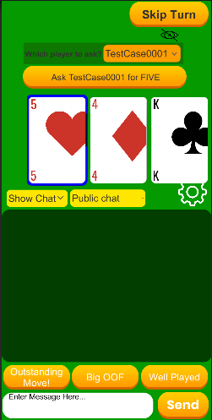

**Test 2**

1. Start VirtuCardClient application
2. Click the button labeled “Sign In”
3. Enter “virtucards01@gmail.com” into the text input labeled “Enter email…”
4. Enter “Testing1” into the text input labeled “Enter password…”
5. Press the button labeled “Login”
6. A window should appear saying “Login Success”
7. Press the OK button that appears on that window
8. Start VirtuCardHost application
9. Repeat steps 2-7 but on the VirtuCardHost application, but use “virtucards02@gmail.com” as the email and use “Testing1” as the password
10. Select the “GoFish” option from the game choices dropdown
11. The checkbox “Allow host to Join” should be checked on the host
12. Press the Create Game button
13. On the VirtuCardClient application enter the 6-character room code found on the host’s screen into the field labeled “Enter Code…”
14. Press the Join Game button on the client
15. Start another VirtuCardClient application
16. Repeat steps 2-7 on the new VirtuCardClient application, but use “virtucards02@gmail.com” as the email and use “Testing1” as the password
17. After both players have joined, press the start game button on the VirtuCardHost application.
18. On either of the clients, press the Hide Cards button

**Expected Result:** There is a vibration indicating that buttons are now disabled and cards are flipped over.

**VirtuCard Client:**

Cards flipped over

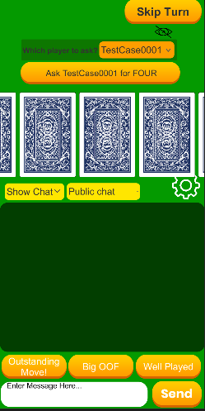

**Test 3**

1. Start VirtuCardClient application
2. Click the button labeled “Sign In”
3. Enter “virtucards01@gmail.com” into the text input labeled “Enter email…”
4. Enter “Testing1” into the text input labeled “Enter password…”
5. Press the button labeled “Login”
6. A window should appear saying “Login Success”
7. Press the OK button that appears on that window
8. Start VirtuCardHost application
9. Repeat steps 2-7 but on the VirtuCardHost application, but use “virtucards02@gmail.com” as the email and use “Testing1” as the password
10. Select the “Uno” option from the game choices dropdown
11. The checkbox “Allow host to Join” should be checked on the host
12. Press the Create Game button
13. On the VirtuCardClient application enter the 6-character room code found on the host’s screen into the field labeled “Enter Code…”
14. Press the Join Game button on the client
15. Start another VirtuCardClient application
16. Repeat steps 2-7 on the new VirtuCardClient application, but use “virtucards02@gmail.com” as the email and use “Testing1” as the password
17. After both players have joined, press the start game button on the VirtuCardHost application.
18. On either of the clients, play a valid card that matches either the color or number of the card shown on the host screen.

**Expected Result:** There is no vibration as a valid card is played.

**VirtuCard Client:**

Valid card selected

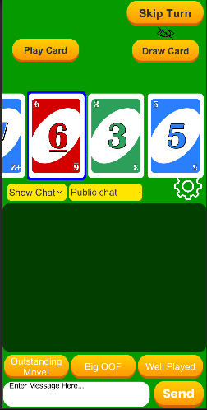

**VirtuCard Host:**

Card being show on the host (to be matched)

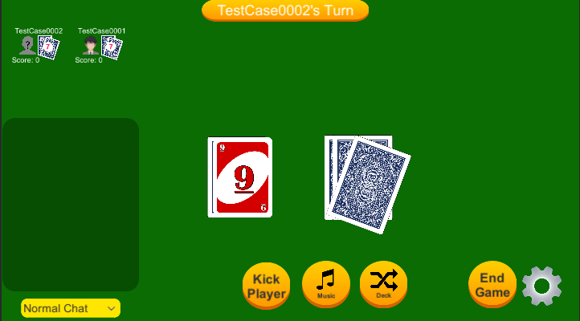

**Test 4**

1. Start VirtuCardClient application
2. Click the button labeled “Sign In”
3. Enter “virtucards01@gmail.com” into the text input labeled “Enter email…”
4. Enter “Testing1” into the text input labeled “Enter password…”
5. Press the button labeled “Login”
6. A window should appear saying “Login Success”
7. Press the OK button that appears on that window
8. Start VirtuCardHost application
9. Repeat steps 2-7 but on the VirtuCardHost application, but use “virtucards02@gmail.com” as the email and use “Testing1” as the password
10. Select the “Uno” option from the game choices dropdown
11. The checkbox “Allow host to Join” should be checked on the host
12. Press the Create Game button
13. On the VirtuCardClient application enter the 6-character room code found on the host’s screen into the field labeled “Enter Code…”
14. Press the Join Game button on the client
15. Start another VirtuCardClient application
16. Repeat steps 2-7 on the new VirtuCardClient application, but use “virtucards02@gmail.com” as the email and use “Testing1” as the password
17. After both players have joined, press the start game button on the VirtuCardHost application.
18. On either of the clients, play an invalid card that does not match the color and number of the card shown on the host screen.

**Expected Result:** There is a vibration indicating that a user has attempted to play an invalid card.

**VirtuCard Client:**

Invalid card selected and played

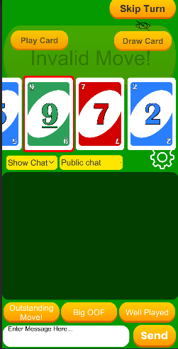

Invalid message along with vibration

**VirtuCard Host:**

Card being show on the host (to be matched)

